**Assignment – 1**

1. Write a program on Histogram Equalization for global enhancement. A plot of the histogram before and after the equalization should also be shown. You may Run your algorithm on MATLAB/PYTHON/C and print out the histogram on the screen, or plot it

**Justification**: The Image I have chosen is moon’s surface image and used histogram equalization to enhance the visible features in the image, for color image equalization I took an image with low brightness to improve it’s visibility.

**Code:**

For monochrome:

import cv2

import numpy as np

import matplotlib.pyplot as plt

from graph_helper import plot_graph

def myEqualizeHist(img):

    hist,bins=np.histogram(img.flatten(),256,[0,256])

    cdf=np.cumsum(hist)

    cdf_m=np.ma.masked_equal(cdf,0)

    cdf_m=(cdf_m-cdf_m.min())*255/(cdf_m.max()-cdf_m.min())

    cdf_final=np.ma.filled(cdf_m,0).astype('uint8')

    img=cdf_final[img]

    return img

def main(path,function):

    img=cv2.imread(path,0)

    plot_graph.display_histogram(img,'Image before Equalization')

    equalized_img=function(img)

    plot_graph.display_histogram(equalized_img,'Image after Equalization')

    comp_stack=np.hstack((img,equalized_img))

    cv2.imshow('Image before and after histigram equilization',comp_stack)

    cv2.waitKey(0)

    cv2.destroyAllWindows()

if __name__=='__main__':

    print('Predefined Histogram Equalizer')

    main('./images/moon-crater.jpeg',cv2.equalizeHist)

    print('My Histogram Equalizer')

    main('./images/moon-crater.jpeg',myEqualizeHist)

**Outputs:**

Predefined:

Histograms:

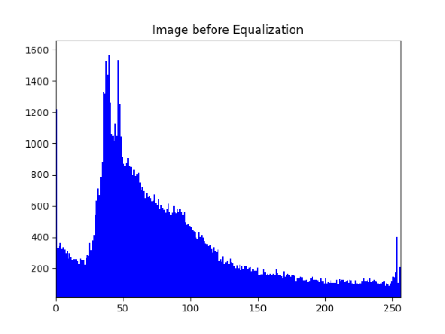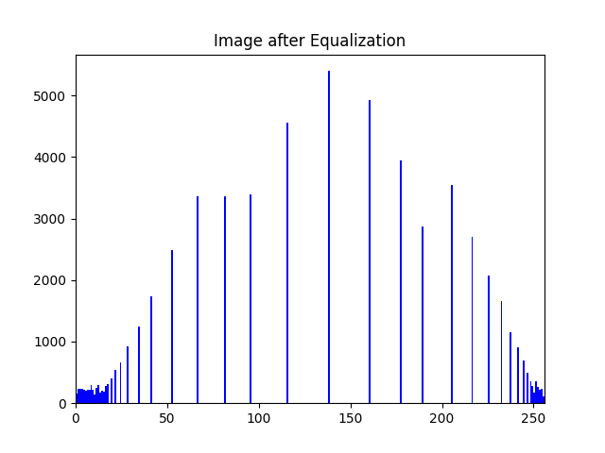

Images:

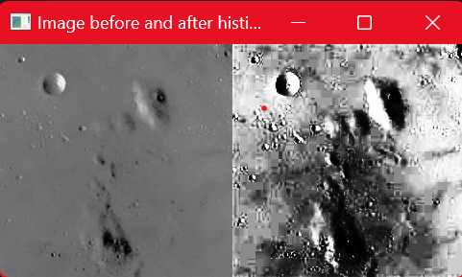

User Defined:

Histogram

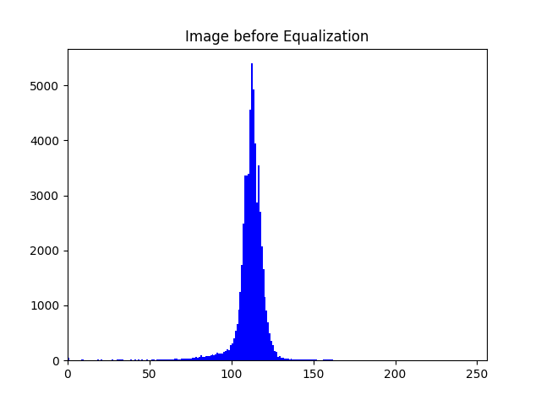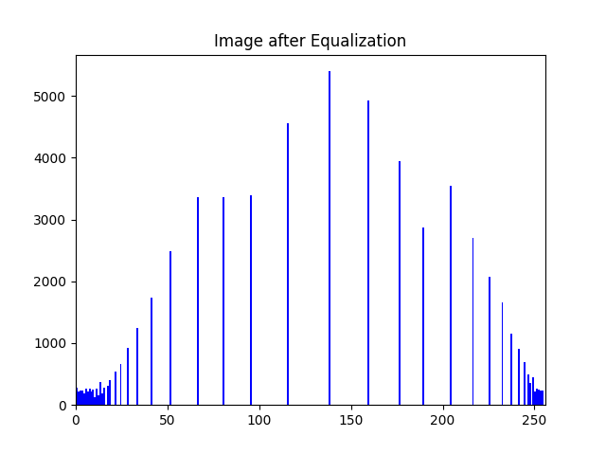

Images:

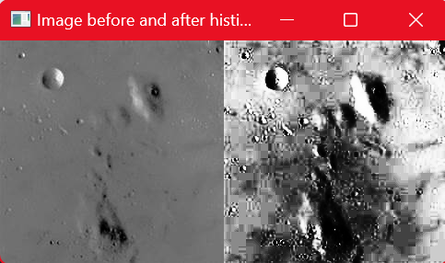

**For Color**:

import cv2

import numpy as np

from PIL import Image

from graph_helper import plot_graph

def hist_equalizer(color):

    h,bin_b=np.histogram(color.flatten(),256,[0,256])

    cdf=np.cumsum(h)

    cdf_m=np.ma.masked_equal(cdf,0)

    cdf_m=(cdf_m - cdf_m.min())*255/(cdf_m.max()-cdf_m.min())

    cdf_final=np.ma.filled(cdf_m,0).astype('uint8')

    return cdf_final[color]

def myhistogram_equalization(img):

    blue,green,red=cv2.split(img)

    equ_b=hist_equalizer(blue)

    equ_g=hist_equalizer(green)

    equ_r=hist_equalizer(red)

    equ=cv2.merge((equ_b,equ_g,equ_r))

    return equ

def histogram_equalization(img):

    blue,green,red=cv2.split(img)

    equ_b=cv2.equalizeHist(blue)

    equ_g=cv2.equalizeHist(green)

    equ_r=cv2.equalizeHist(red)

    equ=cv2.merge((equ_b,equ_g,equ_r))

    return equ

if __name__=='__main__':

    orginal=cv2.imread('./images/moon-crater-colors.jpeg')

    plot_graph.display_histogram(orginal,'Histogram before Equalization')

    #final=histogram_equalization(orginal)

    final=myhistogram_equalization(orginal)

    plot_graph.display_histogram(final,'Histogram after Equalization')

    stacked = np.hstack((orginal,final))

    cv2.imshow('Before and After',stacked)

    cv2.waitKey(0)

    cv2.destroyAllWindows()

**Outputs**:

Predefined:

Histograms:

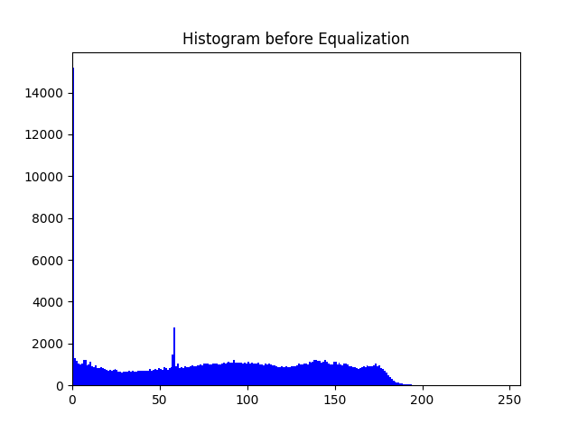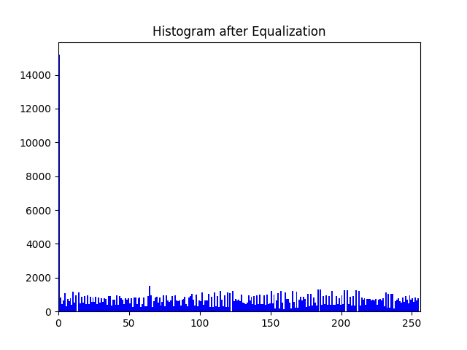

Images:



1. Convert rgb2gray to convert it from RGB to Monochrome

**Code:**

import cv2

import numpy as np

import PIL.Image as im

def convert_to_grayscale(image_path):

    img=cv2.imread(image_path)

    B,G,R=cv2.split(img)

    gray=0.299*R + 0.587*G + 0.114*B

    return im.fromarray(gray)

if __name__ == "__main__":

    grayscale_image=convert_to_grayscale('./images/black-hole.jpeg')

    grayscale_image.show()

**Output:**

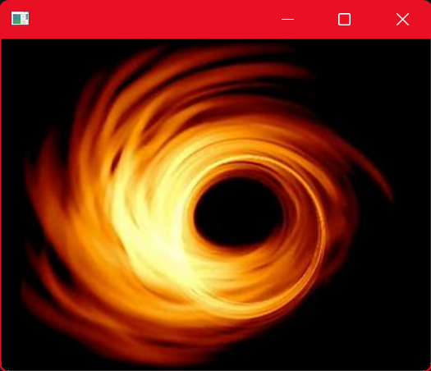 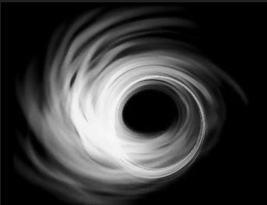

1. Make use of RGB2HSI and experiment it in HIS color model

**Code**:

import cv2

from PIL import Image

from matplotlib import pyplot as plt

import numpy as np

from graph_helper import plot_graph

def buildin_rgb_hsi(path):

    image=cv2.imread(path)

    plot_graph.display_histogram(image,'Histogram of RGB image')

    hsv_image=cv2.cvtColor(image, cv2.COLOR_BGR2HSV)

    plot_graph.display_histogram(hsv_image,'Histogram of HSV image')

    Image.fromarray(hsv_image).show()

    cv2.waitKey(0)

    cv2.destroyAllWindows()

if __name__=='__main__':

    buildin_rgb_hsi('./images/colors.jpeg')

**Output**:

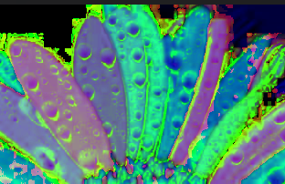

1. Make it poor contrast:
2. Dark Image (Subtract/Gamma correction), Bright Image (Add/Gamma Correction)

**Code**:

import numpy as np

import cv2

from matplotlib import pyplot as plt

import numpy as np

from graph_helper import plot_graph

def adjust_gamma(image,gamma=1.0):

    img_normalized = img/255.0

    corrected_img = np.power(img_normalized, gamma)

    corrected_img = np.uint8(corrected_img * 255)

    return corrected_img

def plot_gamma_transformation(image,gamma=1.0):

    adjusted_image=adjust_gamma(image,gamma)

    original_pixels=image.flatten()

    adjusted_pixels=adjusted_image.flatten()

    plt.figure(figsize=(8,6))

    plt.scatter(original_pixels,adjusted_pixels,alpha=0.1,s=1)

    plt.plot([0,255],[0,255],color='red',linestyle='--')

    plt.title(f'Gamma Correction (Gamma={gamma})')

    plt.xlabel('Original Pixel Value')

    plt.ylabel('Adjusted Pixel Value')

    plt.xlim([0,255])

    plt.ylim([0,255])

    plt.grid(True)

    plt.show()

if __name__=='__main__':

    path=input("Enter the path of image: ")

    gamma=float(input("Enter the gamma falue \n>1 - Darken\n<1 - lighten\n1-same image\n"))

    img=cv2.imread(path)

    plot_graph.display_histogram(img,'Histogram before Adjusting brightness')

    gamma_corrected=adjust_gamma(img,gamma)

    plot_graph.display_histogram(gamma_corrected,f'Histogram after Adjusting brightness gamma={gamma}')

    stacked=np.hstack((img,gamma_corrected))

    cv2.imshow('Orginal and Gamma corrected image',stacked)

    cv2.waitKey(0)

    cv2.destroyAllWindows()

    plot_gamma_transformation(img,gamma)

**Output**:

Brighter Image: -(Gamma 2.5)

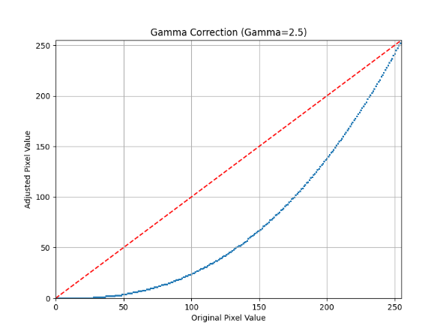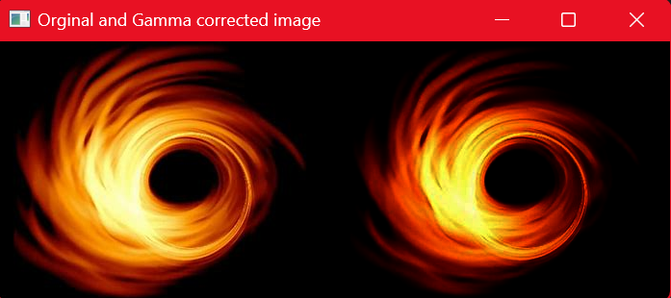

Lighter Image: - (Gamma 0.5)

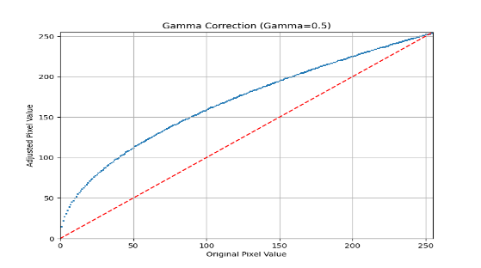 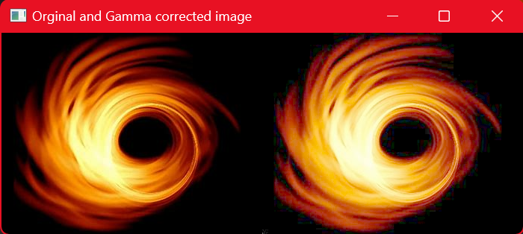

1. Low contrast (Thresholding) , High Contrast (a high contrast image usually exhibits a bimodal histogram with clear separation between the two predominant modes)

**Code**:

import numpy as np

from graph_helper import plot_graph

import cv2

import numpy as np

def low_contrast(path):

    image=cv2.imread(path,0)

    plot_graph.display_histogram(image,'Histogram before applying Threshold')

    _,thresholded_image=cv2.threshold(image,200,255,cv2.THRESH_BINARY)

    plot_graph.display_histogram(image,'Histogram after applying Threshold')

    stack=np.hstack((image,thresholded_image))

    cv2.imshow('Comparision',stack)

    cv2.waitKey(0)

    cv2.destroyAllWindows()

def high_contrast(path):

    image=cv2.imread(path,0)

    plot_graph.display_histogram(image,'Histogram before CLAHE')

    clahe=cv2.createCLAHE(clipLimit=2.0,tileGridSize=(8,8))

    hc_image=clahe.apply(image)

    plot_graph.display_histogram(hc_image,'Histogram after CLAHE')

    stack=np.hstack((image,hc_image))

    cv2.imshow('Comparision',stack)

    cv2.waitKey(0)

    cv2.destroyAllWindows()

if __name__=='__main__':

    path=input('Enter the path: ')

    low_contrast(path)

    high_contrast(path)

**Output**:

Low Contrast: (Thresholding)

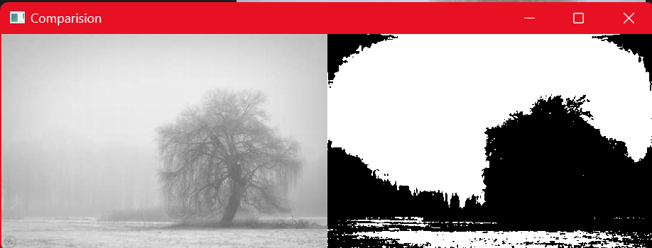

High Contrast: (CLAHE)

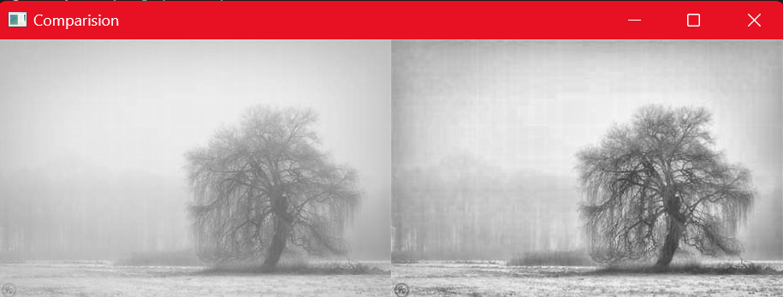

1. Write a program on Log transformation, Gamma correction, image negative and contrast stretching. You may Run your algorithm on MATLAB/PYTHON and print out the histogram on the screen, or plot it. A.
   1. **Log Transformation**

**Code**:

import cv2

import numpy as np

from matplotlib import pyplot as plt

def log_transform(img):

    c=255/np.log(1+np.max(img))

    log_image=c*(np.log(img + 1))

    log_image=np.array(log_image, dtype=np.uint8)

    return log_image

def plot_log_transform(img):

    adjusted_image=log_transform(img)

    original_pixels=img.flatten()

    adjusted_pixels=adjusted_image.flatten()

    plt.figure(figsize=(8,6))

    plt.scatter(original_pixels,adjusted_pixels,alpha=0.1,s=1)

    plt.plot([0,255],[0,255],color='red',linestyle='--')

    plt.title(f'Log Transformation')

    plt.xlabel('Original Pixel Value')

    plt.ylabel('Adjusted Pixel Value')

    plt.xlim([0,255])

    plt.ylim([0,255])

    plt.grid(True)

    plt.show()

if __name__=='__main__':

    img=cv2.imread('./images/log-transform.png')

    log_img=log_transform(img)

    stack=np.hstack((img,log_img))

    cv2.imshow('Orginal vs Log transformed',stack)

    cv2.waitKey(0)

    cv2.destroyAllWindows

    plot_log_transform(img)

**Output**:

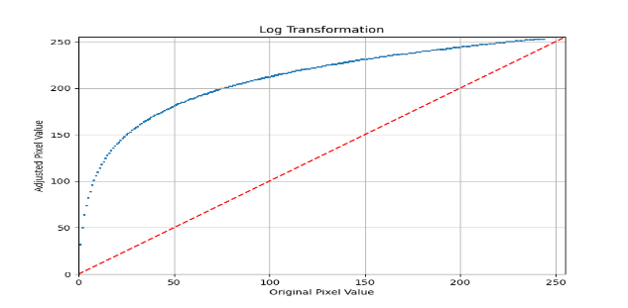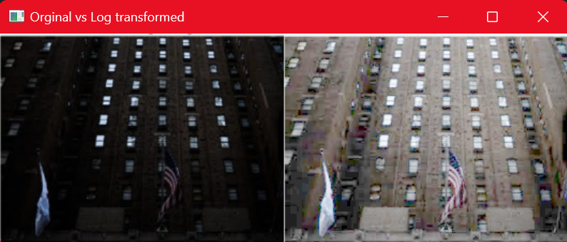

* 1. Gamma Correction

**Code**

Same as brightness adjustment code in 4a

**Output**

Histogram:

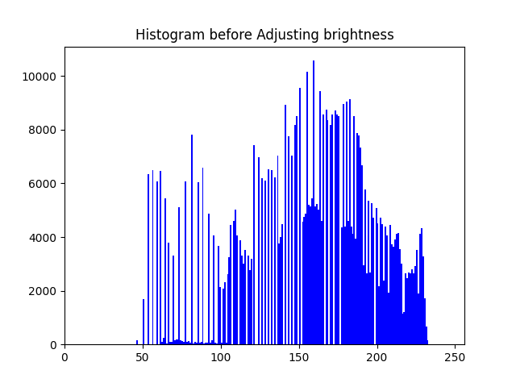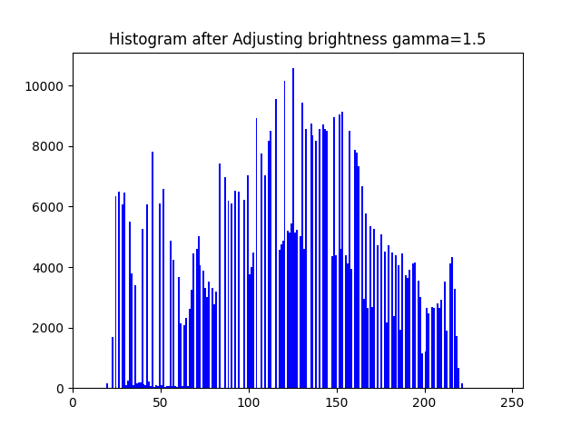

Image:

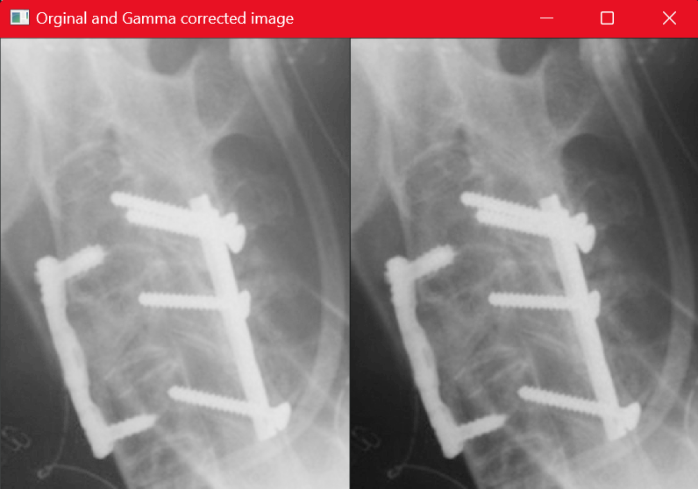

* 1. Image Negative

**Code**:

import cv2

gray=cv2.imread('./images/colors.jpeg',0)

gray_neg=cv2.bitwise_not(gray)

cv2.imshow('Normal Image',gray)

cv2.imshow('Negative Image',gray_neg)

cv2.waitKey(0)

cv2.destroyAllWindows()

**Output**:

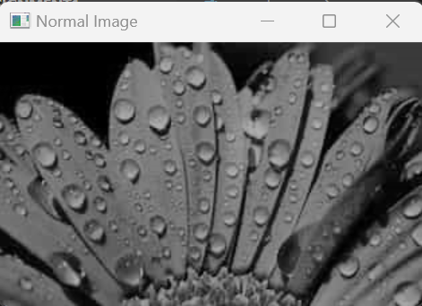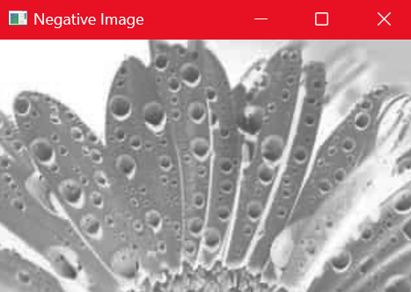

* 1. **Contrast Stretching**

**Code:**

import cv2

import numpy as np

def contrast_stretch(img):

    min_val=np.min(img)

    max_val=np.max(img)

    stretched_img=(img-min_val)*(255.0/(max_val-min_val))

    stretched_img=np.uint8(stretched_img)

    return stretched_img

def contrast_stretch_color(img):

    channels=cv2.split(img)

    stretched_channels=[]

    for channel in channels:

        min_val=np.min(channel)

        max_val=np.max(channel)

        stretched_channel=(channel-min_val)*(255.0/(max_val-min_val))

        stretched_channel=np.uint8(stretched_channel)

        stretched_channels.append(stretched_channel)

    stretched_img=cv2.merge(stretched_channels)

    return stretched_img

def main(path,key=0):

    img=cv2.imread(path,key)

    stretched_img=contrast_stretch(img)

    stack=np.hstack((img,stretched_img))

    cv2.imshow('Original vs Contrast Stretched',stack)

    cv2.waitKey(0)

    cv2.destroyAllWindows()

if __name__=='__main__':

    main('images\low-contrast.jpeg',0)

    main('images\low-contrast.jpeg',3)

**Output:**

Black & White:

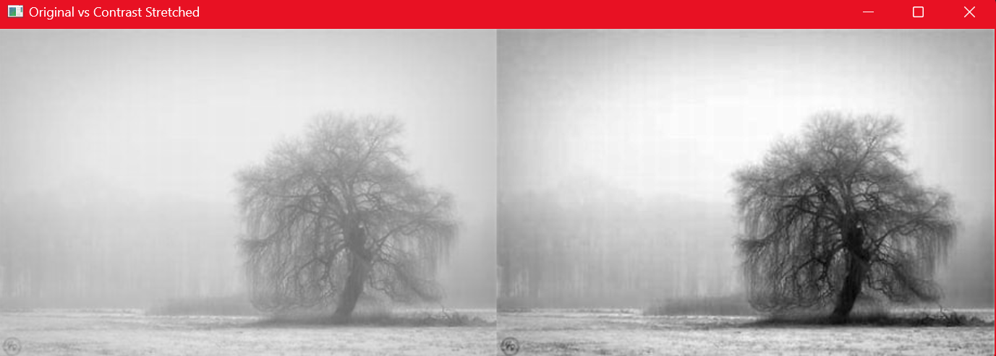

Color:

